Final project

The report prepared by: Lana Al-Batnij

Instructor: Dr. Mohammed Hussein

My ID: 1200308

The date: 24/8/2021

The first system:

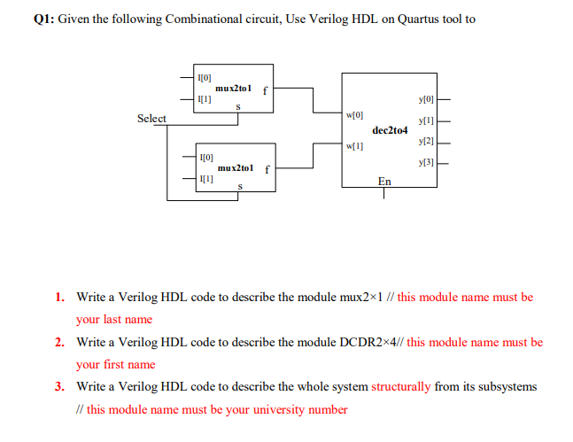

So firstly I write the code for the mux 2x1 and then the decoder 2x4

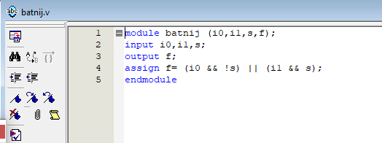

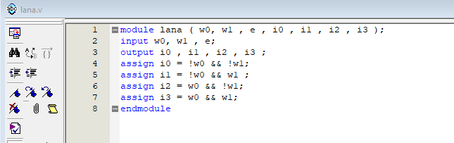

I write the two codes in data flow way.

Then I check my work by the wave form.

The mux:

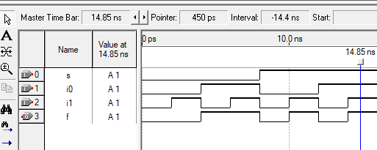

And then the decoder:

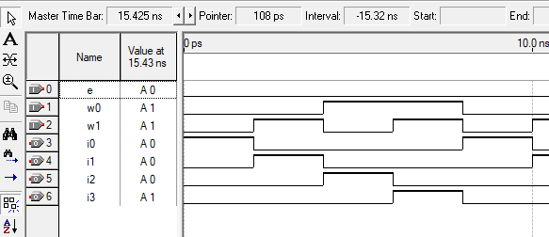

And as a final step I wrote the whole code in structural way.

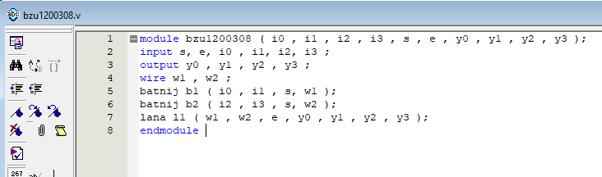

And check the wave form:

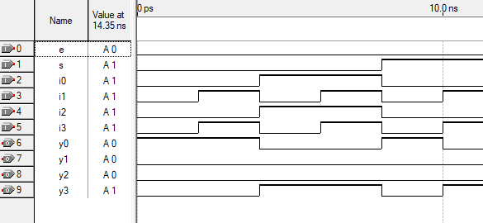

And finally I made the diagram in two ways:

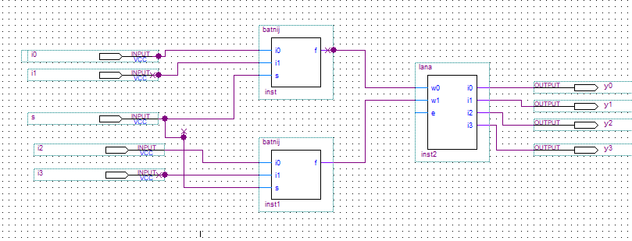

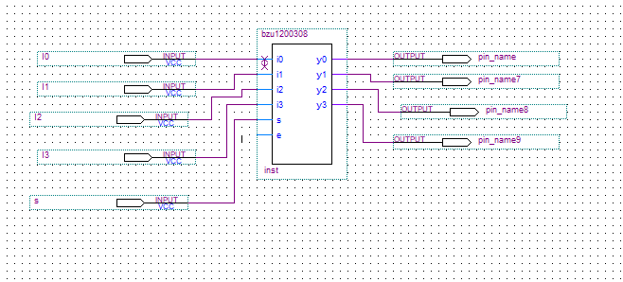

The second system:

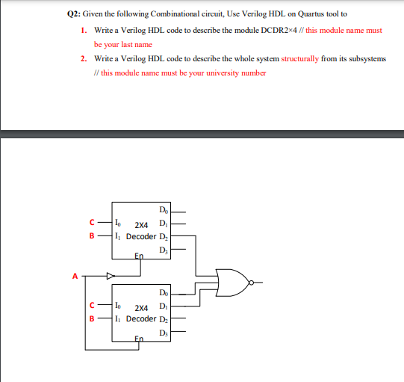

First, I wrote the code of decoder

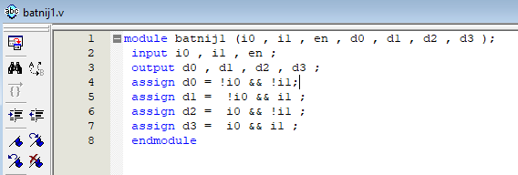

I notice that the first one with low enable active and the second one high enable active , but I didn’t missed up with the code , I just try it out on the wave ; first wave

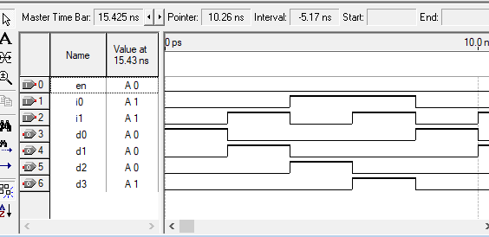

Notice the enable here is 0; the second one the enable will be 1.

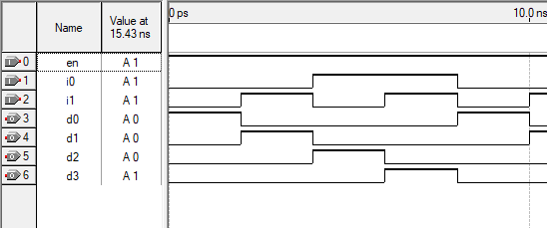

Then I wrote the whole system code structurally

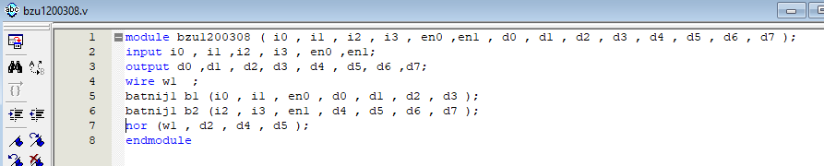

And finally I did the diagram the first one

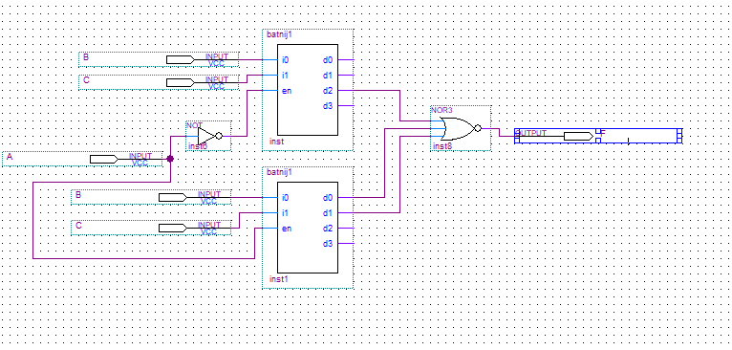

While the whole system in one chip:

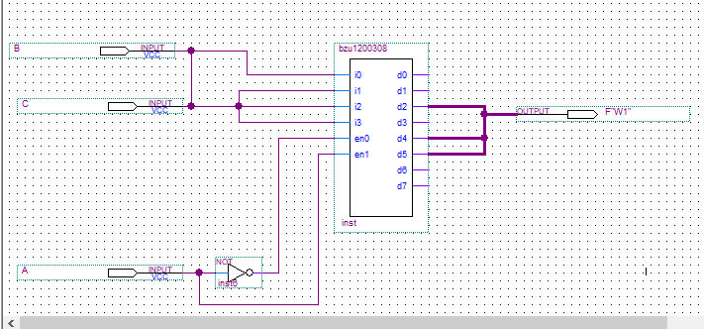

My note about the project:

It was good but I found it kind of tricky, especially in system two; how to deal with the enables.

The end